Step 1 : First I ran this command

docker run -d --name sql_class_pg -e POSTGRES_PASSWORD=postgres -p 5432:5432 postgres:15

Error Faced :
Command 'docker' not found, but can be installed with:
sudo apt install podman-docker # version 3.4.4+ds1-1ubuntu1.22.04.3, or (You will have to enable component called 'universe')
sudo apt install docker.io # version 28.2.2-0ubuntu1~22.04.1 (You will have to enable component called 'universe')

Solution :
Then I ran this command:

sudo apt install podman-docker # version 3.4.4+ds1-1ubuntu1.22.04.3, or (You will have to enable component called 'universe')
sudo apt install docker.io # version 28.2.2-0ubuntu1~22.04.1 (You will have to enable component called 'universe')

Step 2 : Then, I ran this command again
docker run -d --name sql_class_pg -e POSTGRES_PASSWORD=postgres -p 5432:5432 postgres:15

Error Faced :
docker: permission denied while trying to connect to the Docker daemon socket at unix:///var/run/docker.sock: Head "http://%2Fvar%2Frun%2Fdocker.sock/_ping": dial unix /var/run/docker.sock: connect: permission denied

Solution:
(base) saimahmed@pop-os:~$ sudo usermod -aG docker $USER
(base) saimahmed@pop-os:~$ newgrp docker

Step 3 : Then, I ran this command again
docker run -d --name sql_class_pg -e POSTGRES_PASSWORD=postgres -p 5432:5432 postgres:15

Result:

Unable to find image 'postgres:15' locally
15: Pulling from library/postgres
ec781dee3f47: Pull complete
ce2467f2f21d: Pull complete
d4ced18622af: Pull complete
af73ff344a10: Pull complete
07cec992154a: Pull complete
fd0dcffac314: Pull complete
bda354b903ce: Pull complete
fcd98f4944fb: Pull complete
45e04ac2d7d2: Pull complete
f1a2676f0017: Pull complete
eab3f9a27af8: Pull complete
d2c8c030ed3b: Pull complete
c2e686ef6906: Pull complete
b2c40507d19c: Pull complete
Digest: sha256:c635fa3e3b7421a659d34abdfd6d492f679cbe8149e261a501237b55c5a94212
Status: Downloaded newer image for postgres:15
e60e084504e653432a05564d87df4cc943bdd176589f97bd415a85281b67af47

Then I ran this command in terminal
docker exec -it sql_class_pg psql -U postgres

Then create db using this command
CREATE DATABASE psql_db;

Then I installed ‘SQLTools’ Extension in vs code
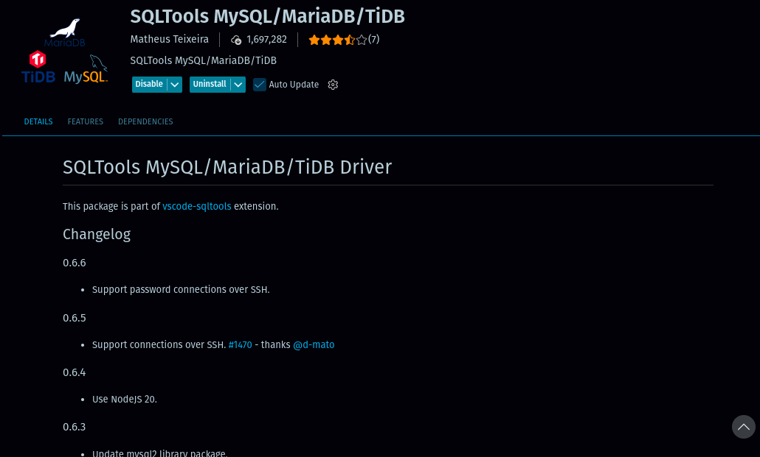
after Installing it appeared in side bar when I clicked it asked me to select Driver But Postgresql not appeared in it

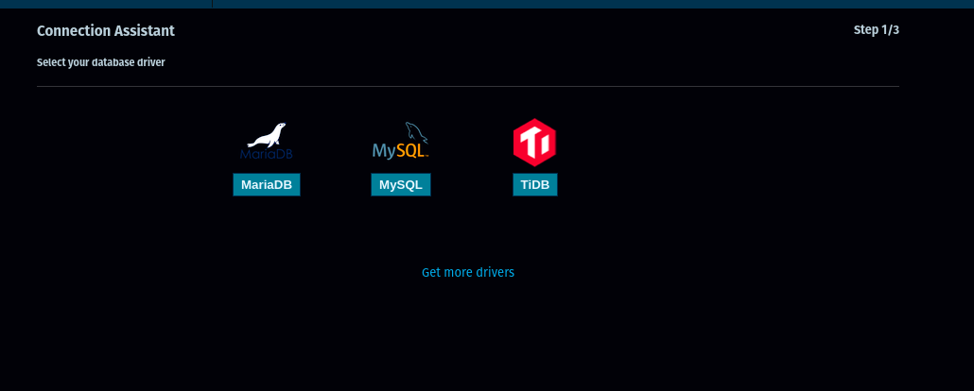

So, I installed another extension

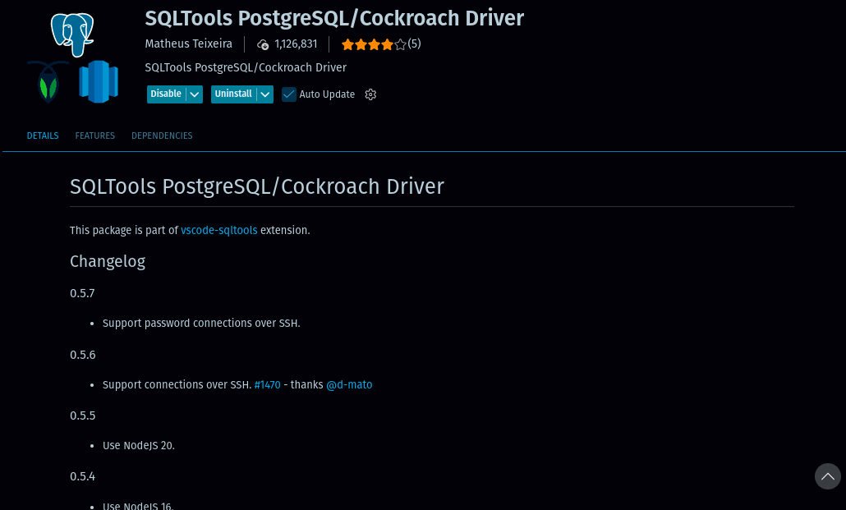
After Installing this , I used this command ‘CTRL+SHIFT+P’ and clicked Restart Extension
Then PostgresQL extension appeared here

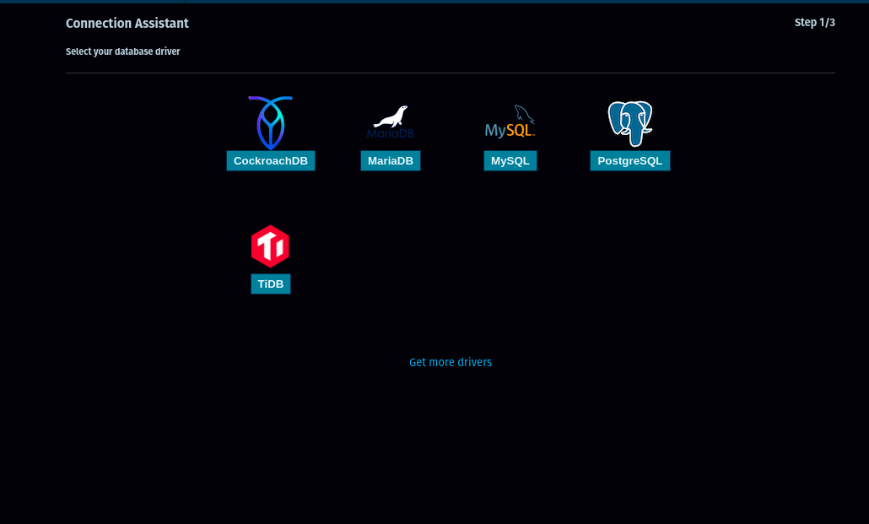

After select postgreSQL From here , connected db
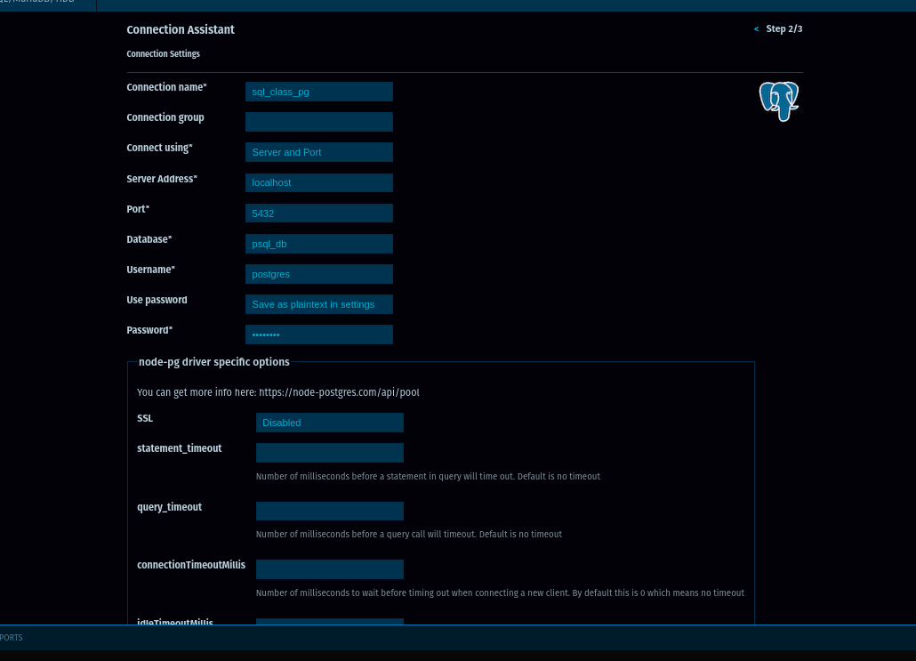
And then to check wethere db is connected , scrolled down and clicked Test connection
